- Data Collection
The data was collected from Coffee Bean Sales Raw Dataset, which was retrieved from kaggle.com under the name of Saad Haroon. An additional file was downloaded from https://simplemaps.com/data/us-zips for assistance in further classifying the data in the Coffee Bean Sales Raw Dataset, which will be mentioned in the “Data Preprocessing” section.

2.0 Data Preprocessing
The dataset had three separate sheets which were “Customers”, “Orders”, and “Products”. The data retrieved was in the form of xlsx file, so when we imported the file, we had to change it to csv form for more efficient data preprocessing.
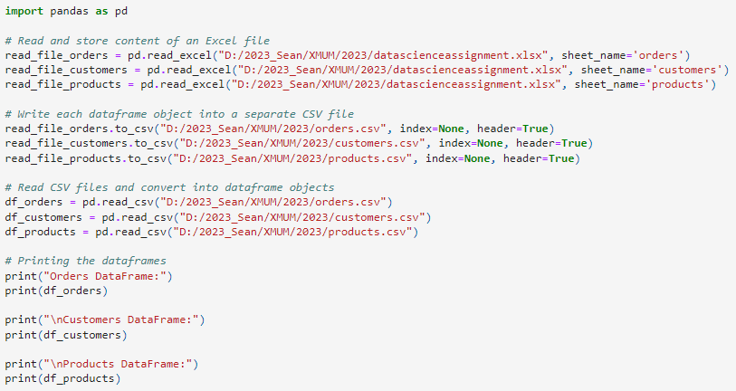
After that, we printed out the three sheets and deleted empty columns in “Orders”.
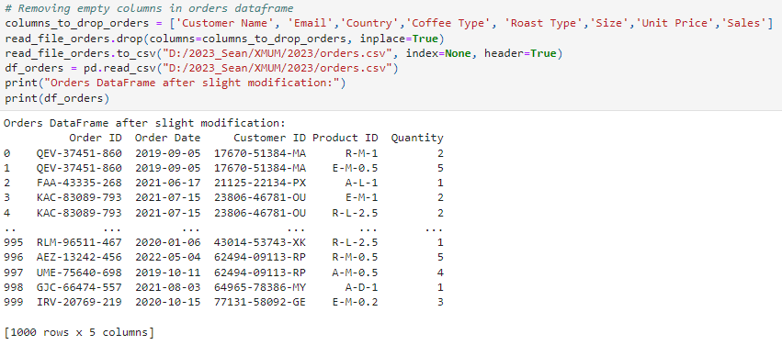
Next, we merged the three sheets together into one data frame so we can conduct our analysis later.
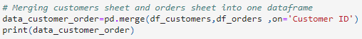
We did another round of checking for empty values, and we found out that all the empty values were located in the “Phone Number” and “Email Address” column. Those two columns are not needed for our objectives, so we dropped these columns along with “Customer Name” and “Address Line 1” to ensure privacy of the customers.
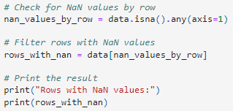
Then, we imported another file uszips which was already in csv form so no modification was needed.
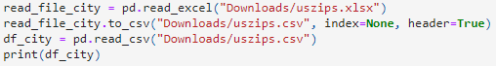
Aside from columns “zip” and “state_name”, all other columns were dropped as they were not needed.
The main goal of importing this file is to classify the cities in the “United States” category under the “Country” column into states. The values of “zip” were grouped together according to their respective states and later renamed to “zip_range”.

Then, it was integrated into our original dataset so the cities can be classified into states according to their zip codes.
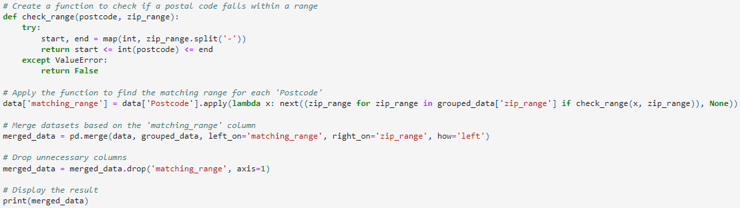 After running a check for empty columns, there were some rows which were in the “United States” category that has yet to be classified into a state. After doing manual checking, these rows are all from “El Paso” under the “City” column. A quick research online tells us that this city is located in Texas, so we added Texas to the “state_name” of these columns replacing the original “NaN” value.
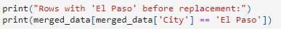

Then we also noticed there is a typo error in the 738th column, where there was a Chinese character among the value under “City” column. We fixed the typo error and the pre-processing was complete.
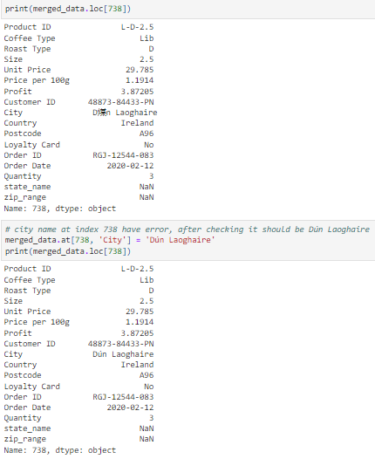
Lastly, the file was saved for preparation of doing data analysis, data analytics and data visualization.

Our target of the data analysis, data analytics and data visualization are to answer to following objectives:
1) Find the correlation of unit price, price per 100g, profit, and quantity.
1a) Is a higher unit price equivalent to more overall profit? Or will a high unit price affect the quantity bought and lower the overall profit?
1b) What is the unit price range that has a high quantity of sales?
2) Finding anomalies in quantity sales. If there are none, we can compare the sales
2a) Analysing profit mean and total sales
2b) Is the most profitable coffee type also the most sold coffee type?
3) Time analysis of total sales
3a) Total sales and sales trend each year
3b) Prediction of sales (quantity)
3c) What coffee type is trending each year?
4) Analyse country sales on coffee bean
4a) How many orders and sales from each country? If there is a country with high sales/orders, do more detailed analysis/analytics on it
4b) What coffee type/roast type/size does each country prefer?
5) Loyalty card
5a) How many customers have loyalty card and how many don’t?
5b) Do customers with loyalty card buy more?

3.0 Data Analysis and Data Analytics with Visualization:
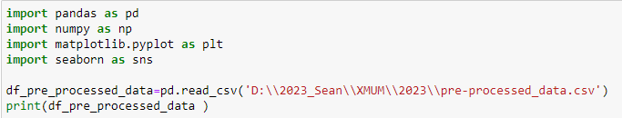
The data set has been preprocessed, and we got a cleaned data set. We will proceed to do some Data Analysis and Data Analytics.

First, we import our data and have a look.

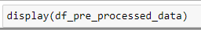
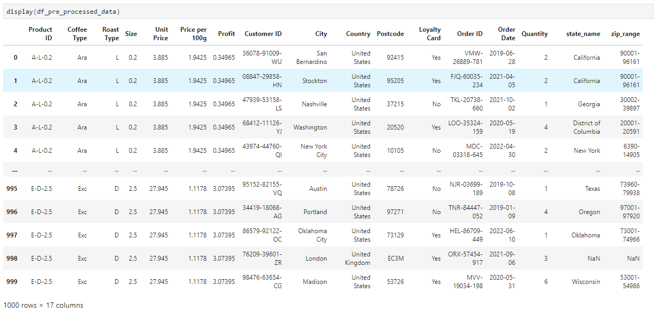

We printed the information of the data set to get better understanding about our data set. Then get summary statistics for numerical columns.

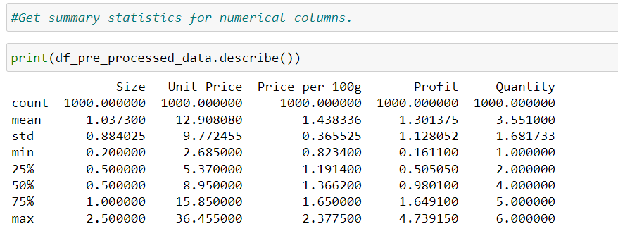

A) Doing some simple analysis and analytics to get an idea

Find the top 5 customers by coffee purchase quantity, the top 5 coffee products by purchase quantity. And the top 5 orders by purchase quantity.
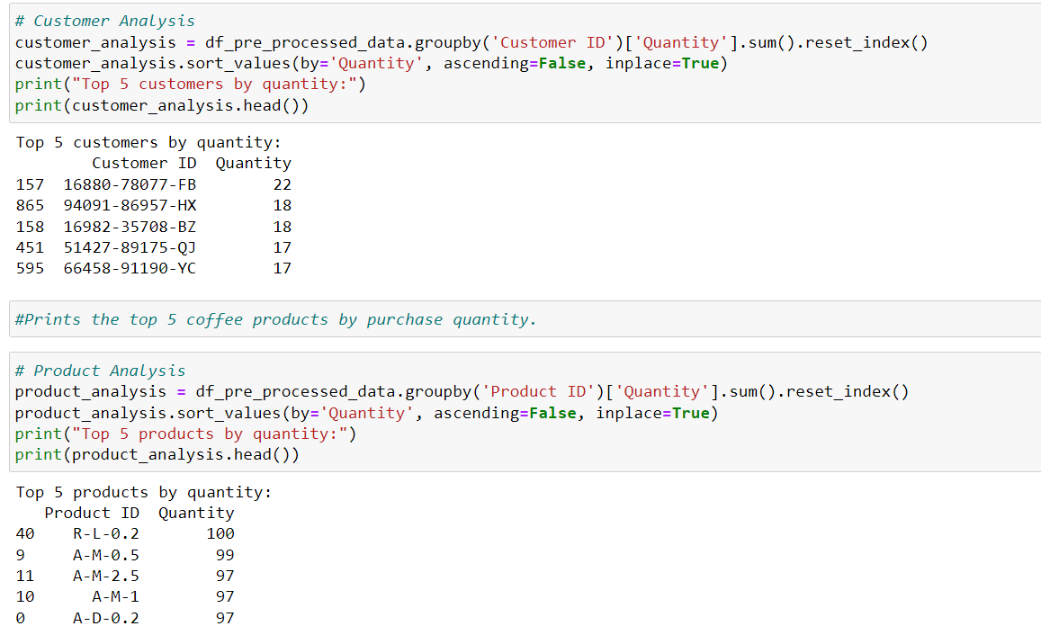

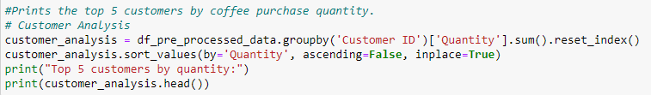



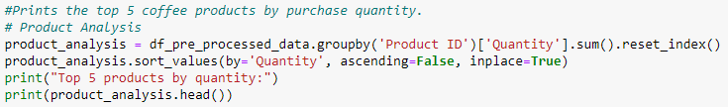

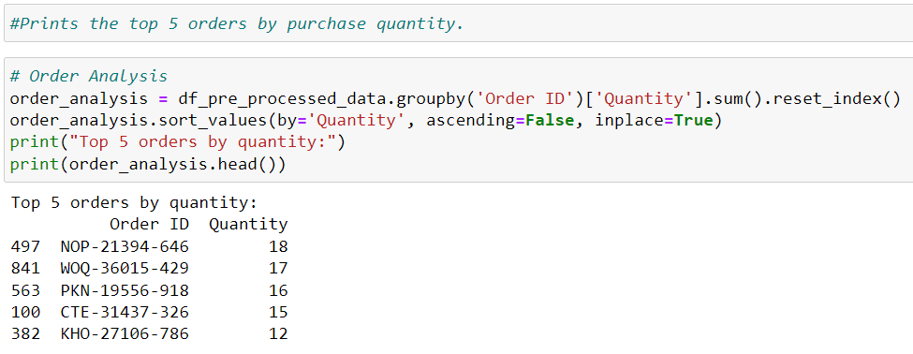

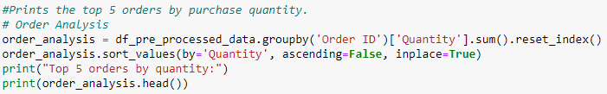

Customer Analysis:
Identifies the top customers based on the total quantity of products they've purchased. Useful for recognizing high-value customers.

Product Analysis:
Highlights the top-selling products based on the total quantity sold. Helps identify popular products.

Order Analysis:
Identifies the top orders based on the total quantity of products ordered. Useful for understanding the impact of specific orders on overall quantity.

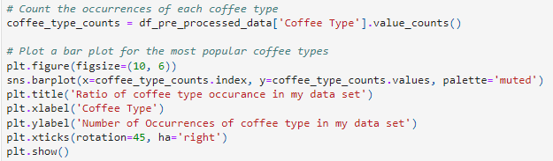
Ratio of coffee type occurrence in our data set.

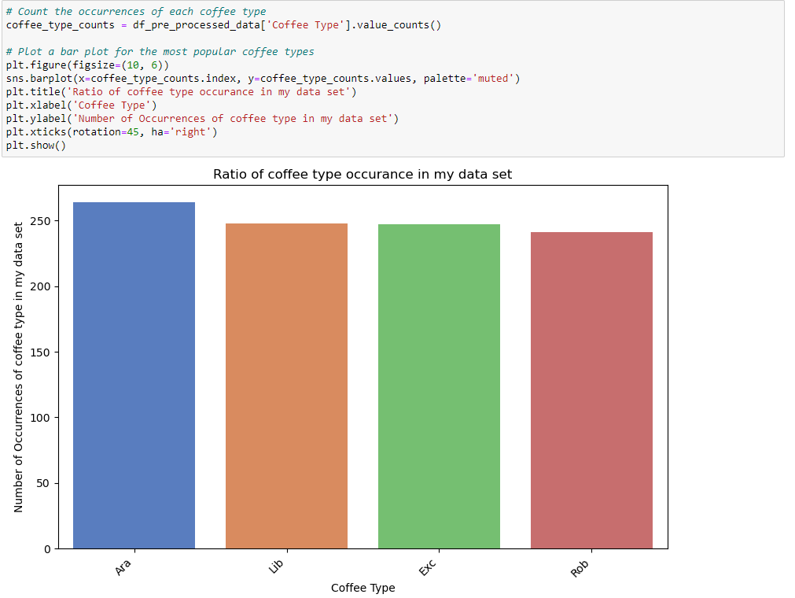

The result indicates that the coffee types appear at an average rate in my data set, so this data set is reliable. The coffee types are Arabica, Liberica, Excelsa and Robusta.
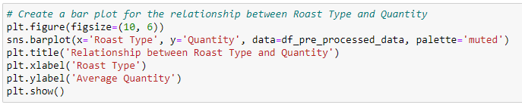

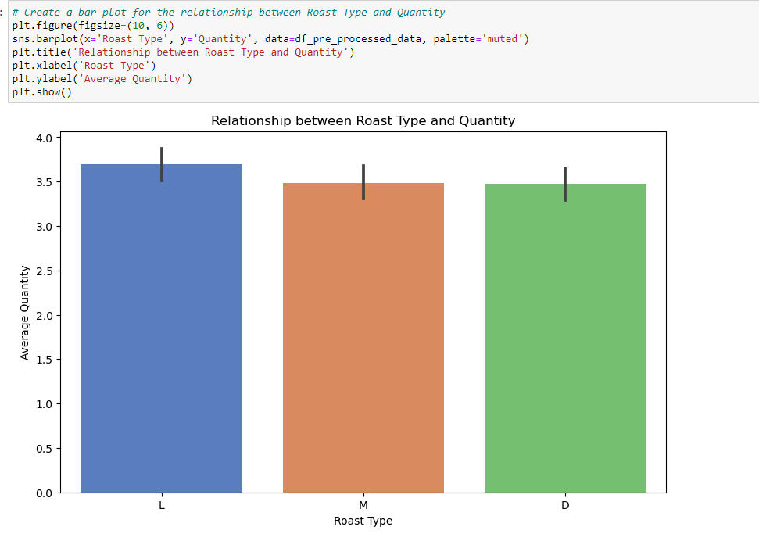

L stands for light, M stands for medium, D stands for Dark. Based on the result, L type is the most popular type of roast. On average, people will buy more light roasted coffee beans at once.
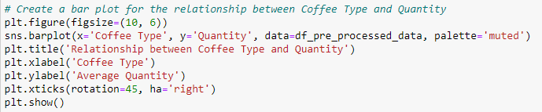

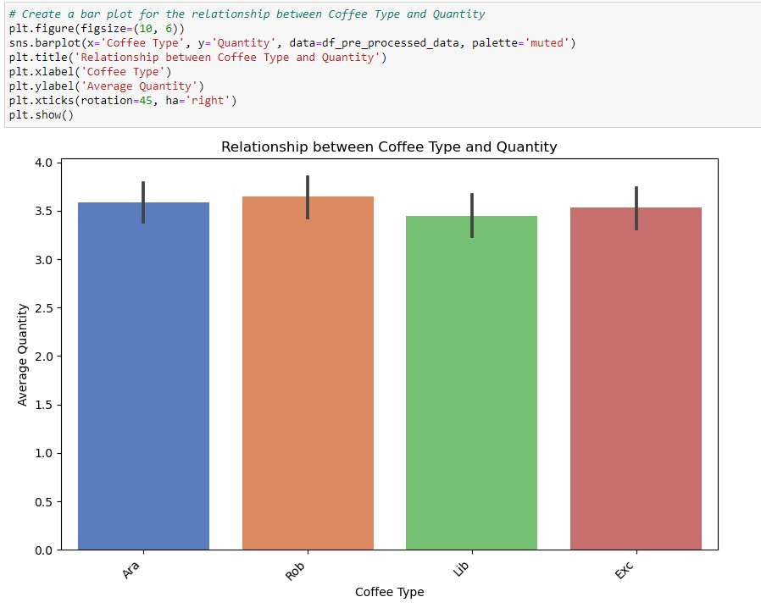

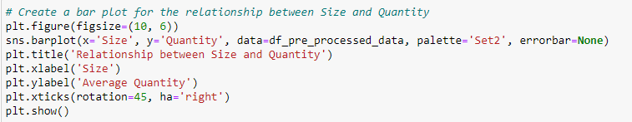
Based on the result, Rob coffee bean has the most loyal customers by a small margin. This is not significant, and will not be counted as a useful insight. To understand if customers prefer a single type of coffee bean, we have to do further analysis.

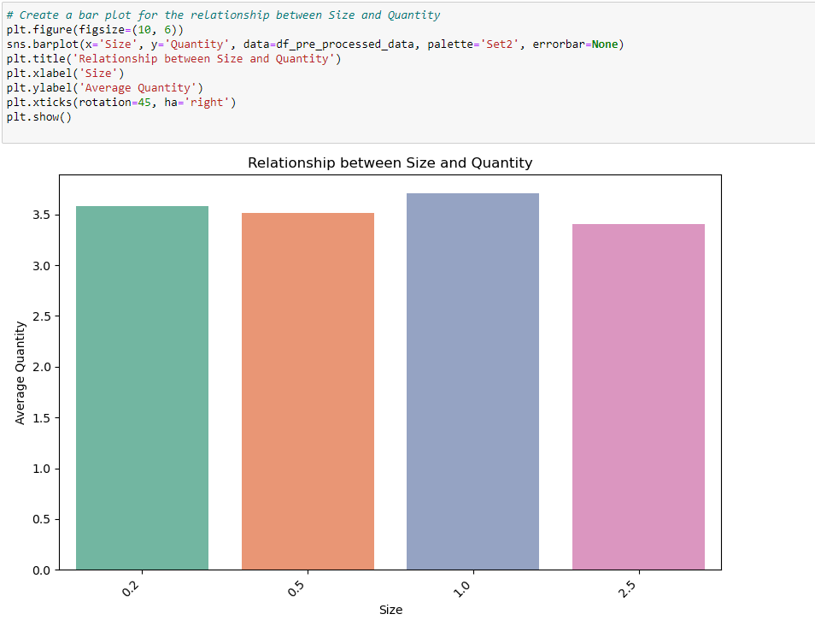

Based on the result, 1.0 is the most popular size of coffee package. We can make an assumption that this could be the standard size of most coffee bean products.

B) Main objectives to find out
1) Find the correlation of unit price, price per 100g, profit, and quantity.
1a) Is a higher unit price equivalent to more overall profit? Or will a high unit price affect the quantity bought and lower the overall profit?
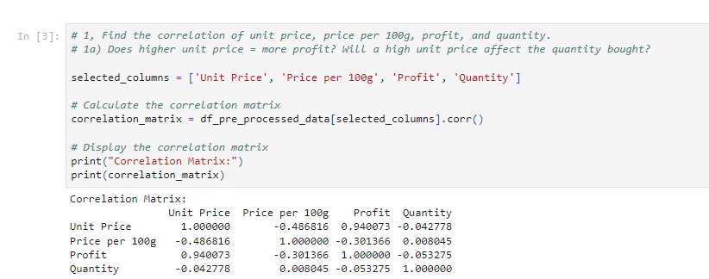
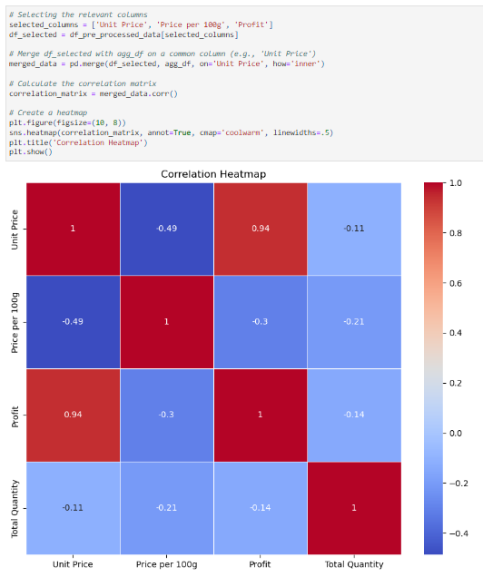
From the correlation matrix, we can see that profit and unit price have strong positive correlations which mean that the higher the unit price, the higher the profit.
Since we found out that quantity and unit price have weak negative correlation, there is little correlation between the two.
From these, we can conclude that a high unit price doesn’t necessarily turn customers away from buying the product. Therefore, it is possible for us to raise the unit price moderately to earn a higher profit.

1b) What is the unit price range that has a high quantity of sales?
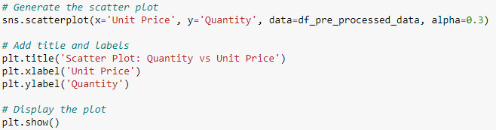

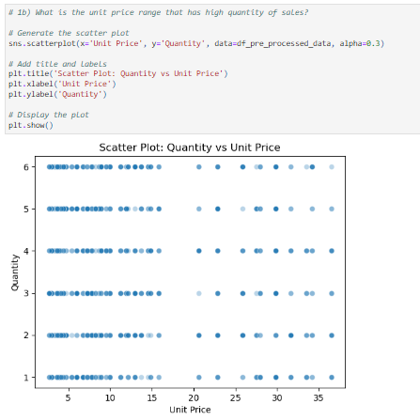

Through the scatter plot, we can see that the highest distribution of sales quantity is at the unit price range between 0-15, the unit price range between 20-40 is moderate, and there is little to no distribution of quantity of sales at the unit price range between 15-20. For a better understanding, please refer to the following distribution graph.
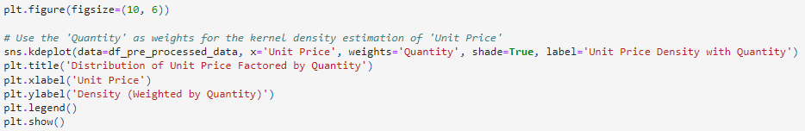

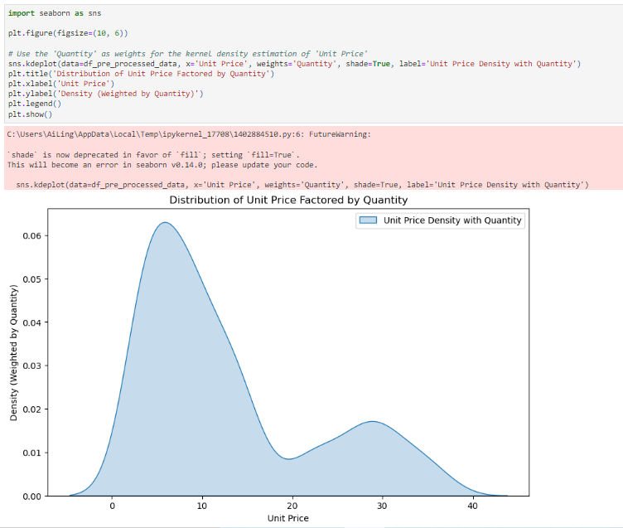

From this, we can say that customers will always choose the cheapest option first to save money. If they have extra money, they are likely to choose more expensive options. Very little people will choose to buy a product which unit price falls near the median. This is very interesting as we initially expected the sales quantity to reach the maximum at the range between 15-25 like a normal distribution does. This phenomenon could probably be explained by the Prospect Theory where people prefer to buy a more expensive coffee type rather than suffering the loss of getting a subpar coffee type. The seller should put more focus on giving expensive products more exposure so more people will buy them.
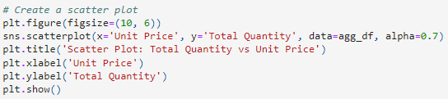
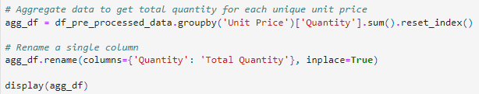

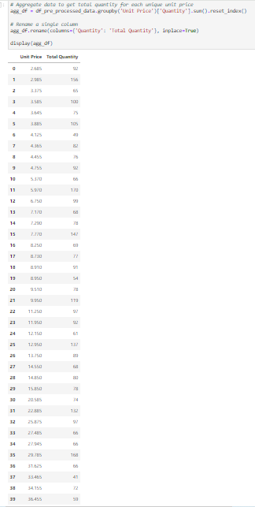
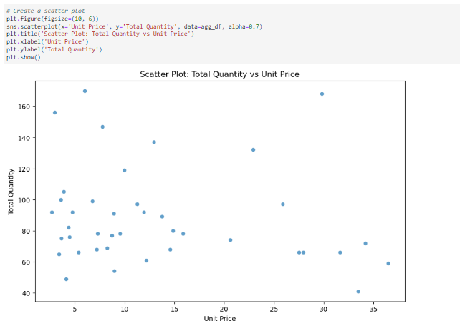

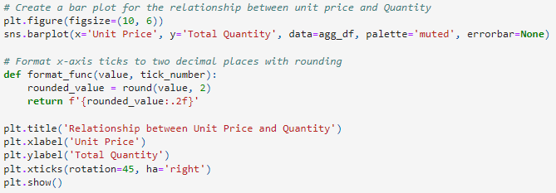

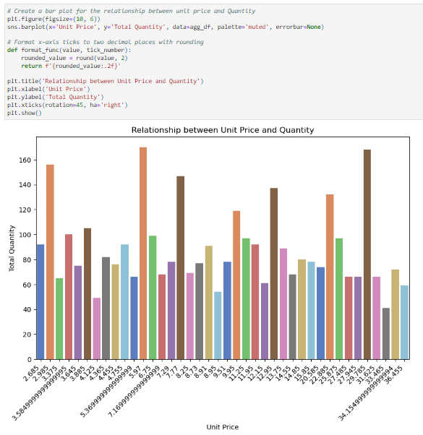

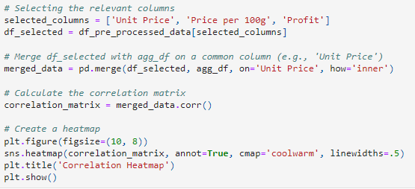
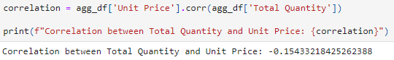

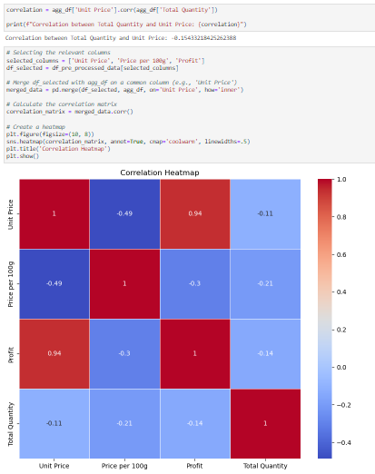

The above were done to see if we could find a relationship between total quantity sold and unit price. However, we were not able to achieve this and we only managed to find the unit prices with the highest quantity sold. Therefore, we did not proceed with any more analysis for this problem.

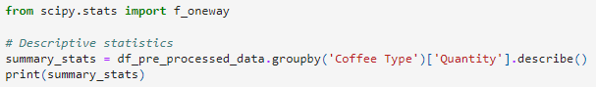
2) Finding anomalies in quantity sales. If there are none, we can compare the sales

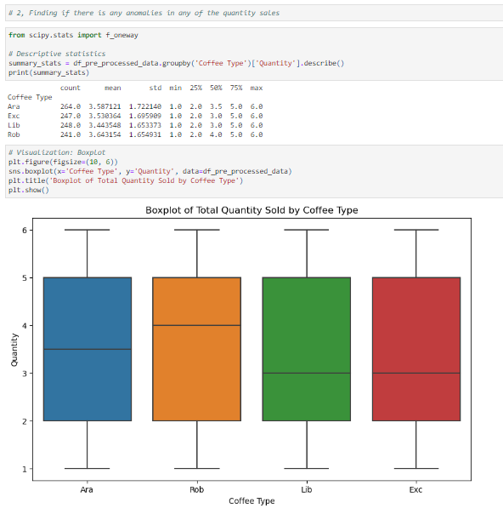

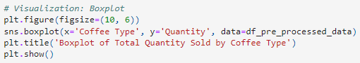



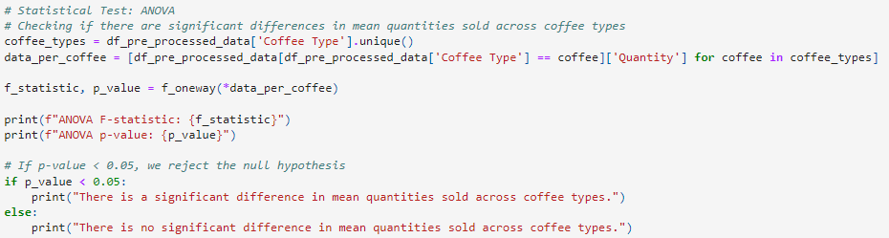
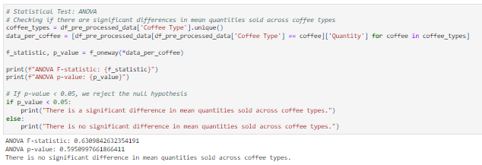

We concluded that there is no significant difference in mean quantities, which means the data is overall fair and not biased when we try to analyse the sales and profits. We can proceed to analyse the sales and profit of the coffee types.

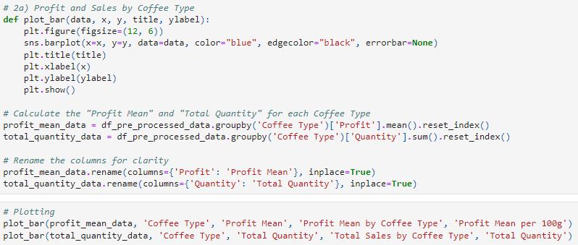
2a) Analysing profit mean and total sales

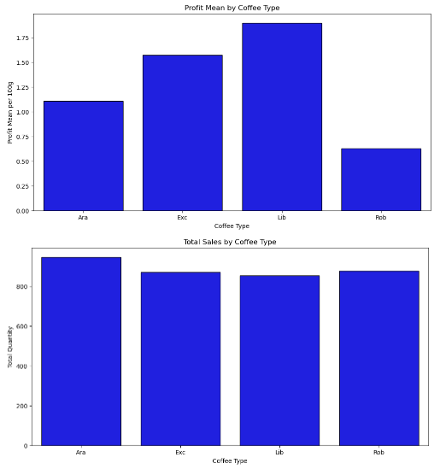

Liberica has the highest profit mean, which means by selling the same quantity of different coffee bean products, Liberica brings in the most profit. As for the second graph, it shows that Ara has a slight advantage in total quantity sold compared to other coffee types. After plotting the two graphs separately, we will do a plot which combines total sales and total profit.
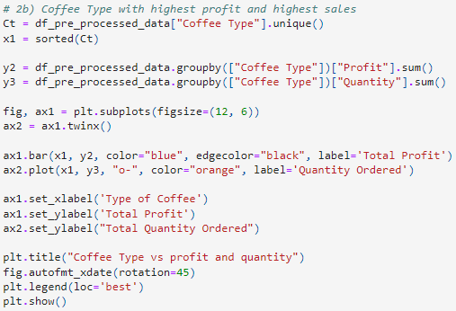
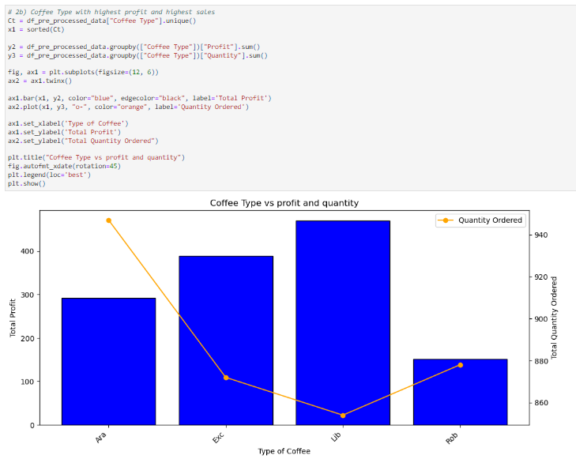From this graph, we have an interesting discovery. Liberica coffee beans has the lowest demand (lowest quantity ordered), yet the total profit it brings is the lowest. On the other hand, Arabica coffee beans has the highest demand (highest quantity ordered), but its total profit is ranked second lowest. We can therefore conclude that the seller should put more focus into promoting Liberica coffee beans as it brings the most profit.

3) Time analysis of total sales
3a) Total sales and sales trend each year
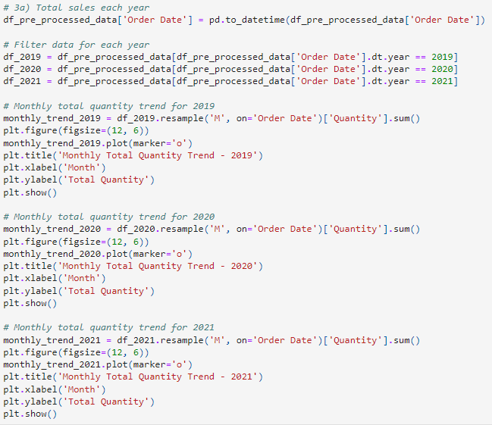
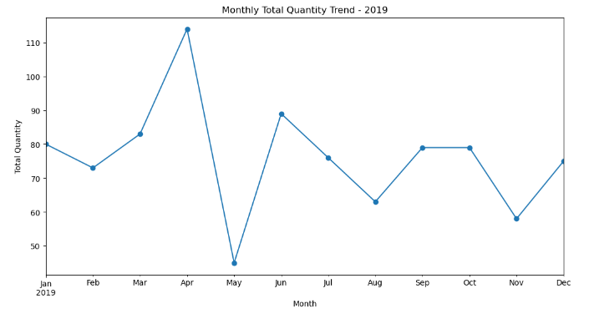
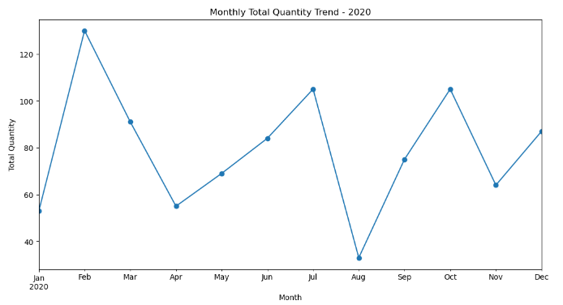
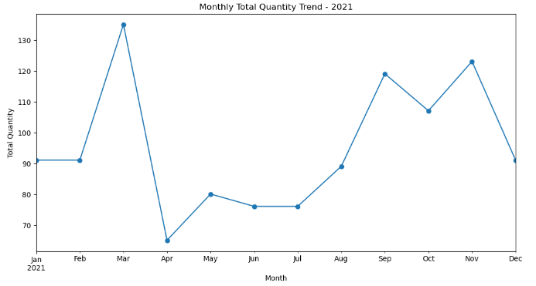
We separated the sales quantity by year and plotted them into different graphs to see if we can find a trend. We noticed that the trend is always increasing at the start of the year, then it plummets around April to May, which is a recurring pattern for all three years. This could be due to the expiry date (or “Best if Used before” date) of the coffee bean product being counted in years. Meaning, if you buy a coffee bean product on January 2018, it may expire on the same month two years later, which is January 2020. This could explain the certain spike in sales every year at the same month. Most people probably bought their products at the start of the year initially, so naturally the product will be finished up or expired by the start of a few years later too. Therefore, customers will buy the products at the same month of the year again.
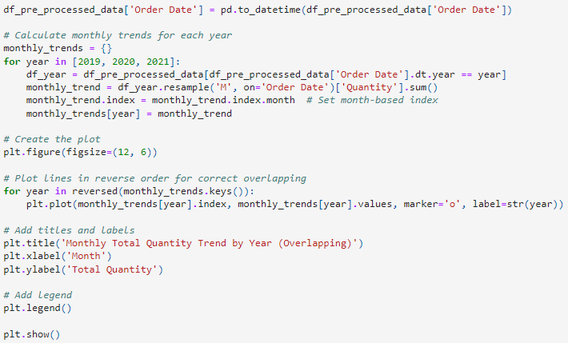
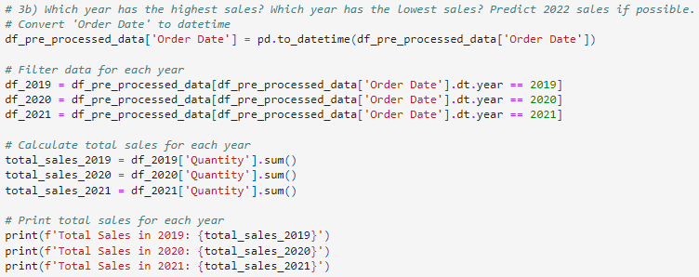
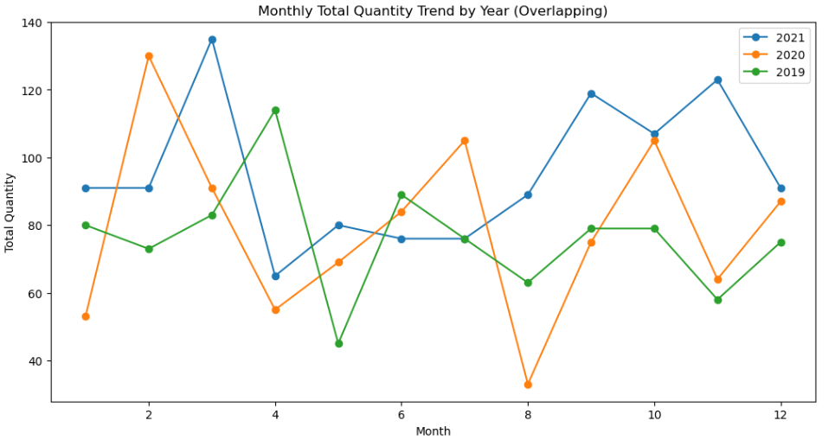
This is overlapping plot of the monthly total quantity trend by year. It is easier to see where the spikes and plummets overlap by doing so.
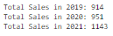
We noticed that 2021 had the most sales. This could be due to the economy recovering from the COVID-19 pandemic, resulting in an increase in sales.

3b) Prediction of sales (quantity)
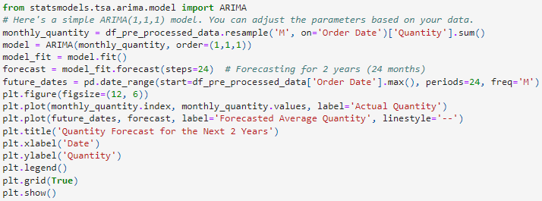
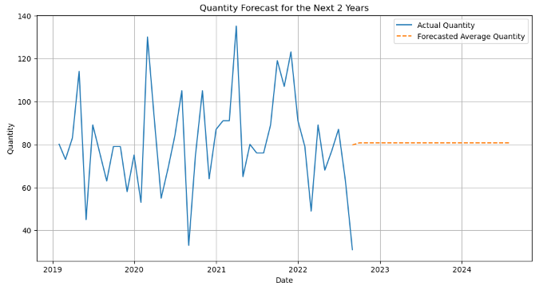
We tried to perform a prediction on the average quantity of sales for the following years. It is not possible to make a prediction on accurate sales as we do not have all the factors that affect the quantity sold.

3c) What coffee type is trending each year?
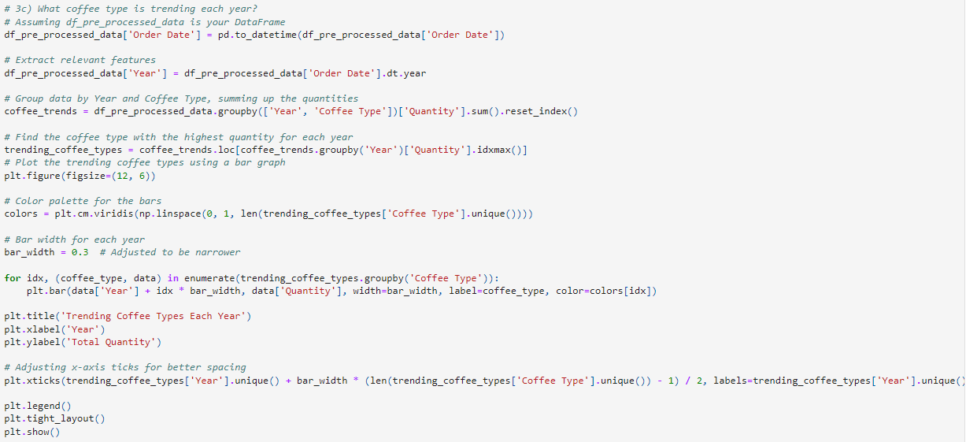
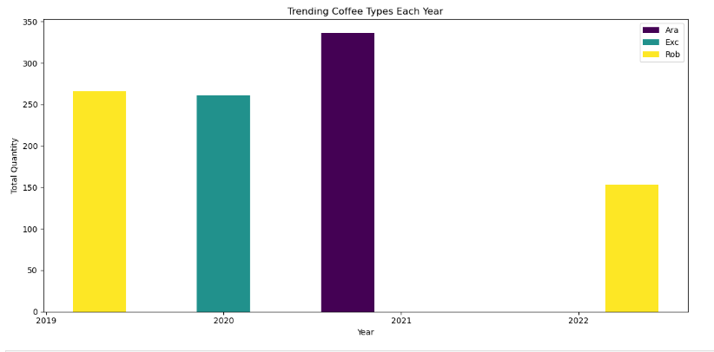
We can see that Liberica is not a popular coffee bean choice. On the other hand, Robusta coffee bean seems to be the overall popular coffee bean choice because it appeared twice in the trending coffee types by year.

4) Analyse country sales on coffee bean
4a) How many orders and sales from each country?
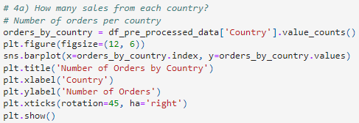
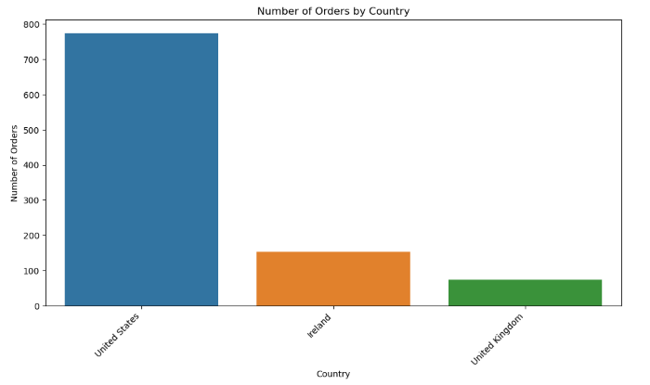
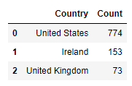

United States contributes most of the orders. However, this could be due to the reason that the seller is a franchised-based business based in United States and had only few branches in Ireland and United Kingdom.

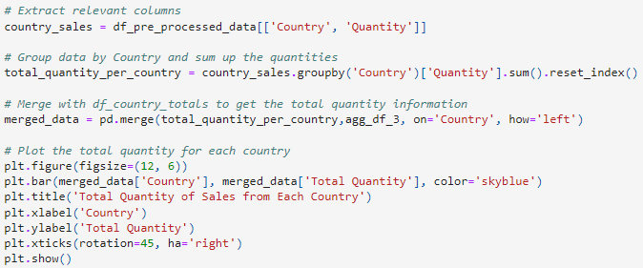
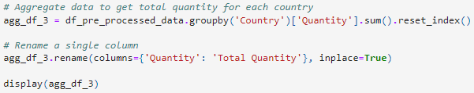
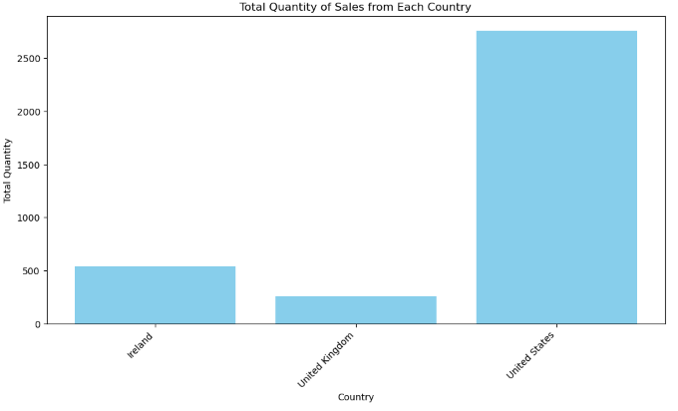
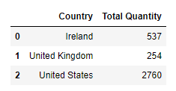

There is not much useful insight we can get from the graph since the difference in sales is too big. All that we can conclude is most of the coffee bean products is sold in the United States. We have decided to do a further analysis into United States by separating it into states. This is what the integration of the us_zips.csv file was for.
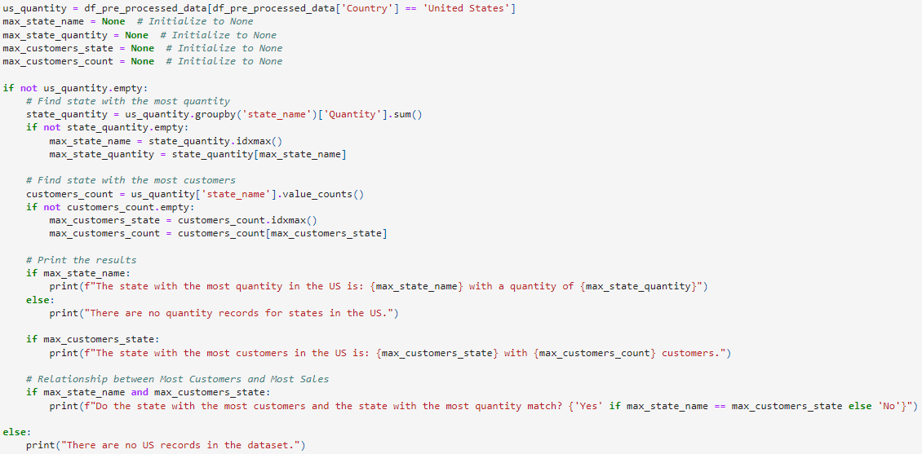
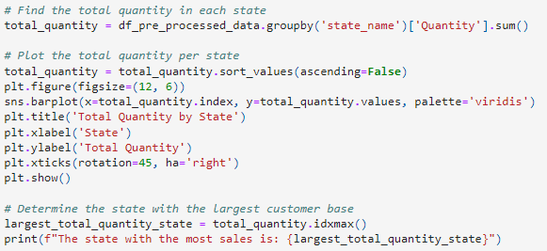

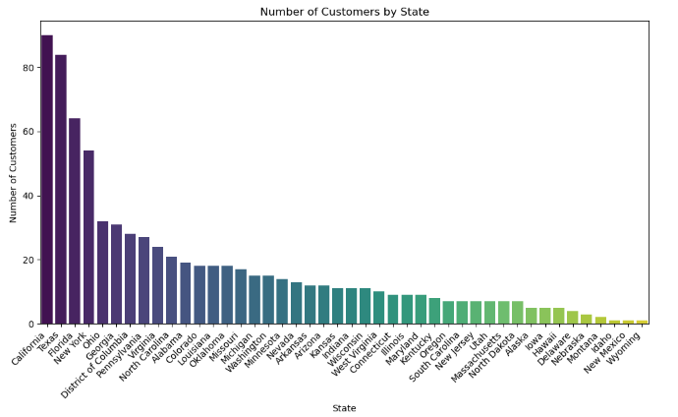
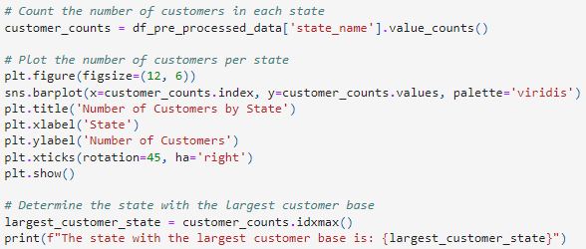
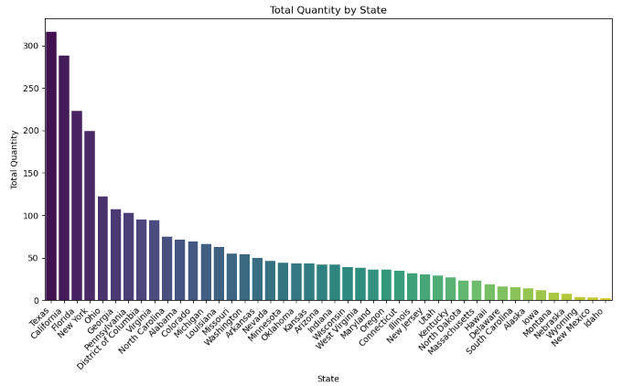
An observation here is that although Texas has the highest quantity, it was not the state with most customers. Instead, California which was second in customers had the highest quantity. We theorized that California bought less products on average, and it could be due to personal preference. Therefore, the seller should focus on Texas more by doing promotions because there is a high chance that the market there is yet to be fully saturated and people there tend to buy higher volumes of products. For the other states, the seller should consider to open more divisions to increase customers and sales.

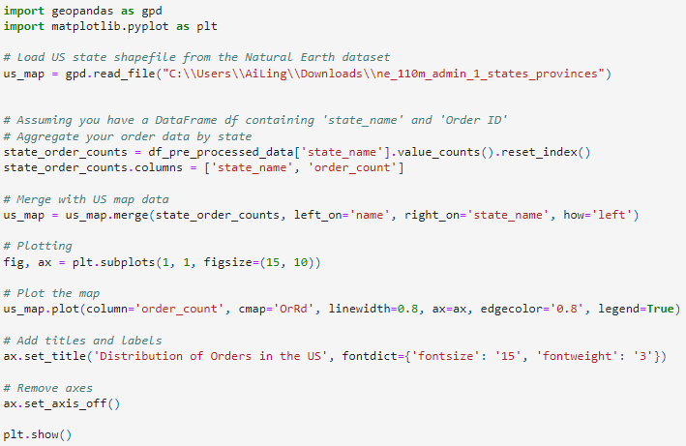
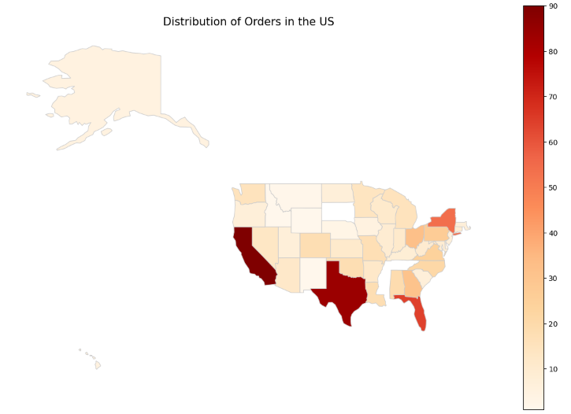
This is another form of visualization of the distribution of orders. From analysing this, we can also theorize that probably the southern part of the US is more used to buying coffee beans than the northern part of the US, which may prefer instant coffee instead. Since instant coffee is more harmful to health, the seller could utilise this point to convince customers to buy coffee beans instead of instant coffee.
4b) What coffee type/roast type/size does each country prefer?
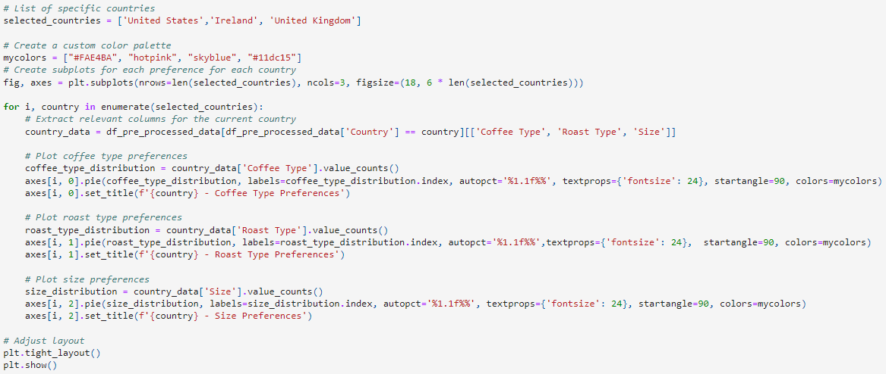
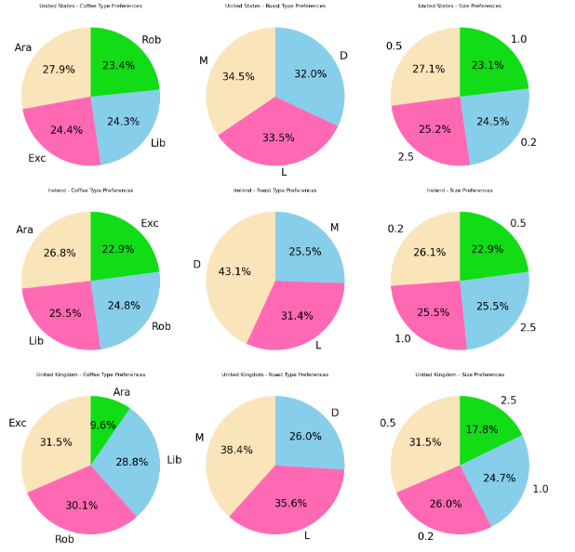
We will list the ones with greater difference:
For Coffee Type: It seems that Arabica coffee type is not popular in the United Kingdom.
For Roast Type: It seems that Dark roast type is very popular in Ireland.
For Size: It seems that 0.5 is quite popular in United Kingdom.

5) Loyalty card
5a) How many customers have loyalty card and how many don’t?
5b) Do customers with loyalty card buy more?
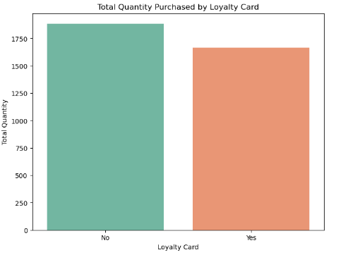
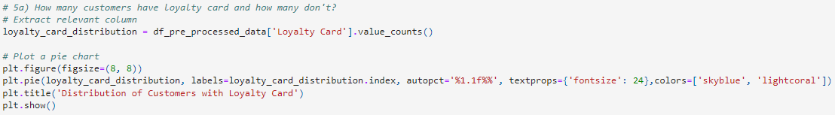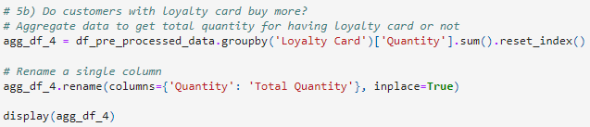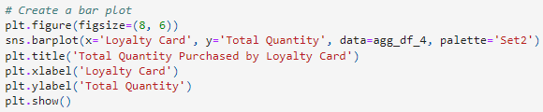
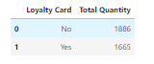

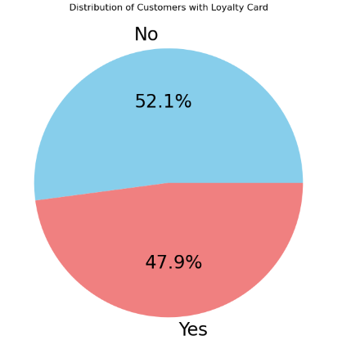

The customers with no loyalty card have a slight majority over those who own one. Unfortunately, there does not seem to be a significant difference between the total quantity purchased, it is also the customers having no loyalty card with more quantity purchased. This could mean that the perks of owning a loyalty card are not good enough to attract customers to buy and spend more on the products.
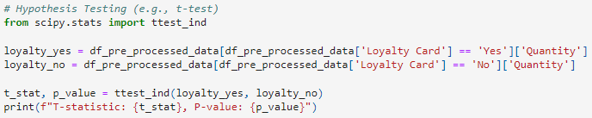
Given the p-value of 0.17637, which is greater than the significance level of 0.05, there is insufficient evidence to reject the null hypothesis. Therefore, we do not conclude that there is a significant difference in mean purchase quantities between customers with and without a loyalty card.

4.0 Conclusion
We have managed to gain insights by following the objectives we set.
1) Find the correlation of unit price, price per 100g, profit, and quantity.
1a) Is a higher unit price equivalent to more overall profit? Or will a high unit price affect the quantity bought and lower the overall profit?
Answer/Insight: In this dataset, the answer is yes. By raising the unit price, there will be more overall profit without having to worry about the reduction in quantities sold. A possible strategy is to raise the unit prices moderately.
1b) What is the unit price range that has a high quantity of sales?
Answer/Insight: The unit price range between 0-15 has the highest quantity of sales. Interestingly enough, the second highest quantity of sales is not the unit price range 15-20. Instead, it is followed by the price range 20-40, and the price range 15-20 has the lowest quantity of sales. A possible explanation is that people either want to save money if they are poor or spend more if they are rich.
2) Finding anomalies in quantity sales. If there are none, we can compare the sales
2a) Analysing profit mean and total sales
Answer/Insight: Liberica has the highest profit mean, which means by selling the same quantity of different coffee bean products, Liberica brings in the most profit. As for the total sales, it shows that Ara has a slight advantage in total quantity sold compared to other coffee types.
2b) Is the most profitable coffee type also the most sold coffee type?
Answer/Insight: Liberica coffee beans has the lowest demand (lowest quantity ordered), yet the total profit it brings is the lowest. On the other hand, Arabica coffee beans has the highest demand (highest quantity ordered), but its total profit is ranked second lowest. It can be concluded that the seller should put more focus into promoting Liberica coffee beans as it brings the most profit for them.
3) Time analysis of total sales
3a) Total sales and sales trend each year
Answer/Insight: The trend is always increasing at the start of the year, then it plummets around April to May. It is a recurring pattern for all three years. This could be due to the expiry date (or “Best if Used before” date) of the coffee bean product being counted in years. This could explain the certain spike in sales every year at the same month. Most people probably bought their products at the start of the year initially, so naturally the product will be finished up or expired by the start of a few years later too. Therefore, customers will buy the products at the same month of the year again.
3b) Prediction of sales (quantity)
Answer/Insight: The prediction is that average sales will be around 80 for the year 2022. An advanced prediction involving fluctuations is not possible as there is no clear relationship between the factors that affect the sales.
3c) What coffee type is trending each year?
Answer/Insight: Liberica is not a popular coffee bean choice. On the other hand, Robusta coffee bean seems to be the overall popular coffee bean choice.
4) Analyse country sales on coffee bean
4a) How many orders and sales from each country? If there is a country with high sales/orders, do more detailed analysis/analytics on it
Answer/Insight: United States contributes most of the orders. We theorized that this could due to be the lack of franchisees in other nations. We suggested that the owner/seller could open more divisions to reach more customers. Additionally, we decided to include the analysis for the states in United States as it had the most sales.
4b) What coffee type/roast type/size does each country prefer?
Answer/Insight:
For Coffee Type: It seems that Arabica coffee type is not popular in the United Kingdom.
For Roast Type: It seems that Dark roast type is very popular in Ireland.
For Size: It seems that 0.5 is quite popular in United Kingdom.
5) Loyalty card
5a) How many customers have loyalty card and how many don’t?
Answer/Insight: There is a slight majority of customers who don’t have loyalty card compared to those who have one.
5b) Do customers with loyalty card buy more?
Answer/Insight: There does not seem to be a significant difference between the total quantity purchased. A possible explanation is the perks of owning a loyalty card are not good enough to attract customers to buy and spend more on the products. The seller should focus on giving out better perks to those who own loyalty cards so the customer who have the loyalty cards will buy and spend more.

